**Structure of this paper**

|  |  |  |  |  |  |  |
| --- | --- | --- | --- | --- | --- | --- |
| Section | Number of questions available | Number of questions to be answered | Suggested working time (minutes) | Marks available | Percentage of examination | Marks  attained |
| Section One  Multiple-choice | 30 | 30 | 40 | 30 | 30 |  |
| Section Two  Short answers | 8 | 8 | 90 | 100 | 50 |  |
| Section Three  Extended answers | 3 | 2 | 50 | 40 | 20 |  |
|  |  |  |  | **Total** | 100 | % |

**Instructions to candidates**

1. The rules for the conduct of the Western Australian examinations are detailed in the *Year 12 Information Handbook 2019*. Sitting this examination implies that you agree to abide by these rules.

2. Write your answers in this Question/Answer booklet preferably using a blue/black pen. Do not use erasable or gel pens.

3. Answer the questions according to the following instructions.

Section One: Answer all questions on the separate Multiple-choice answer sheet provided. For each question, shade the box to indicate your answer. Use only a blue or black pen to shade the boxes. Do not use erasable or gel pens. If you make a mistake, place a cross through that square, then shade your new answer. Do not erase or use correction fluid/tape. Marks will not be deducted for incorrect answers. No marks will be given if more than one answer is completed for any question.

Section Two: Write your answers in this Question/Answer booklet. Wherever possible, confine your answers to the line spaces provided.

Section Three: Consists of three questions. You must answer two questions. Tick the box next to the question you are answering. Write your answers in the separate Answer booklet provided.

4. You must be careful to confine your answers to the specific questions asked and to follow any instructions that are specific to a particular question.

5. Supplementary pages for planning/continuing your answers to questions are provided at the end of this Question/Answer booklet. If you use these pages to continue an answer, indicate at the original answer where the answer is continued, i.e. give the page number.

**Section One: Multiple–choice 30% (30 Marks)**

This section has **30** questions. Answer **all** questions on the separate Multiple-choice Answer Sheet provided. For each question shade the box to indicate your answer. Use only a blue or black pen to shade the boxes. Do not use erasable or gel pens. If you make a mistake, place a cross through that square, then shade your new answer. Do not erase or use correction fluid/tape. Marks will not be deducted for incorrect answers. No marks will be given if more than one answer is completed for any question.

Suggested working time: 40 minutes

1. In a DNA molecule, adenine pairs with

(a) adenine.

(b) guanine.

(c) thymine.

(d) uracil.

2. Muscle tissue may be smooth or striated. Smooth muscle would be found in the

(a) intestinal and bronchial walls.

(b) facial muscles.

(c) heart muscle.

(d) limb muscles.

3. The digestive products absorbed into the lacteal of a villus are

(a) glucose.

(b) amino acids.

(c) nucleic acids.

(d) fatty acids and glycerol.

4. The chemical building blocks of carbohydrates are

(a) monosaccharides.

(b) polysaccharides.

(c) nucleotides.

(d) monopeptides.

5. Scientists consider epigenetics to be the study of

(a) the alteration of the expression of a gene, in addition to changing the gene structure.

(b) the complete set of genetic information of an organism.

(c) the production of a protein using the information encoded in a gene.

(d) the alteration of the expression of a gene without changing the gene structure.

6. How many sex chromosomes does a normal female inherit from her mother?

(a) 46

(b) 2

(c) 23

(d) 1

**Question 7 relates to the information and tables below.**

Students were asked to design an investigation to determine the effect of changing pH levels on enzyme activity. Four students’ designs are shown below.

E = Enzyme

S = Substrate

**Design I Design II**

|  |  |  |  |
| --- | --- | --- | --- |
| **Tube number** | **Contents** | **pH** | **Temp (℃)** |
| 1 | E | 3 | 20 |
| 2 | E | 7 | 20 |
| 3 | E | 12 | 20 |
| 4 | S | 3 | 20 |
| 5 | S | 7 | 20 |
| 6 | S | 12 | 20 |

|  |  |  |  |
| --- | --- | --- | --- |
| **Tube number** | **Contents** | **pH** | **Temp (℃)** |
| 1 | E+S | 3 | 20 |
| 2 | E+S | 7 | 20 |
| 3 | E+S | 12 | 20 |
| 4 | S | 3 | 20 |
| 5 | S | 7 | 20 |
| 6 | S | 12 | 20 |

**Design III Design IV**

|  |  |  |  |
| --- | --- | --- | --- |
| **Tube number** | **Contents** | **pH** | **Temp (℃)** |
| 1 | E+S | 3 | 10 |
| 2 | E+S | 7 | 20 |
| 3 | E+S | 12 | 30 |
| 4 | S | 3 | 20 |
| 5 | S | 7 | 30 |
| 6 | S | 12 | 10 |

|  |  |  |  |
| --- | --- | --- | --- |
| **Tube number** | **Contents** | **pH** | **Temp (℃)** |
| 1 | E+S | 3 | 10 |
| 2 | E+S | 7 | 10 |
| 3 | E+S | 7 | 30 |
| 4 | E | 12 | 10 |
| 5 | E | 12 | 20 |
| 6 | S | 12 | 30 |

7. Which investigation design is the most appropriate?

(a) Design I

(b) Design III

(c) Design II

(d) Design IV

8. Which of the following comparisons between arteries and veins is **not** correct?

|  |  |  |
| --- | --- | --- |
|  | **Arteries** | **Veins** |
| (a) | thick and muscular walls | thin walls |
| (b) | blood at high pressure | blood at low pressure |
| (c) | valves present | valves absent |
| (d) | usually contains blood with low carbon dioxide | usually contains blood with high carbon dioxide |

9. A student completed a genetic exercise by preparing the Punnett square shown below.

|  |  |
| --- | --- |
| TT | Tt |
| Tt | tt |

What were the likely genotypes of the parents?

(a) Parent 1 was homozygous while Parent 2 was heterozygous.

(b) Parent 1 was heterozygous while Parent 2 was homozygous.

(c) Both parents were heterozygous for the trait.

(d) Both parents were homozygous for the trait.

10. An investigation was carried out looking at changes to the composition of blood as it flowed through various organs of the body. Data from one of the organs tested showed an increase in both carbon dioxide and by-products of the digestion process, but a decrease in oxygen levels.

Which of the following organs would be most likely to produce this result?

(a) lungs

(b) small intestine

(c) gall bladder

(d) kidney

11. Variation that occurs as a result of meiosis can be due to

(a) equal numbers of chromosomes.

(b) teratogens.

(c) random mating.

(d) crossing over.

12. The following is a list of steps that occurs in the process of mitosis:

i) formation of two daughter cells

ii) separation of the chromatids

iii) replication of DNA

iv) division of the cytoplasm

v) chromosomes line up along the equator of the cell

Which of the following is the correct order of events in mitosis?

(a) iii, ii, i, iv, v

(b) iv, iii, v, ii, i

(c) v, iv, iii, ii, i

(d) iii, v, ii, iv, i

13. Men are more likely to suffer from X-linked genetic conditions than women because

* + - 1. males carry the Y chromosome.
      2. most X-linked conditions are dominant.
      3. males possess only one X chromosome.
      4. the Y chromosome carries little body information other than “maleness”.

14. In a controlled experiment, a scientist is studying the effect of increasing the resistance whilst pedalling an exercise bike on heart rate. What is the dependent variable?

* 1. the time spent on the bike
  2. the resistance to pedalling the bike
  3. the type of exercise bike
  4. the heart rate

**Question 15 refers to the table below.**

A group of Year 10 pupils carried out a survey of their class. The numbers of attached ear lobes

and unattached ear lobes in the class were counted and recorded. The table below shows the

results.

|  |  |
| --- | --- |
| **Number of pupils** | |
| **Attached ear lobes** | **Unattached ear lobes** |
| 17 | 3 |

15. What type of graph should they use to best represent the data?

(a)line graph

(b) column graph

(c) histogram

(d) scatter graph

16. The two substances that make up the majority of the structure of a cell membrane are

(a) carbohydrates and proteins

(b) lipids and proteins

(c) lipids and fatty acids

(d) myosin and cholesterol

17. Stage three of the labour process involves the

(a) contractions of the uterus, and expulsion of the placenta.

(b) contraction of the uterus and production of colostrum in the breast.

(c)the expulsion of the baby from the birth canal.

(d) an increase in uterine contractions.

**Questions 18 and 19 refer to the diagram below.**

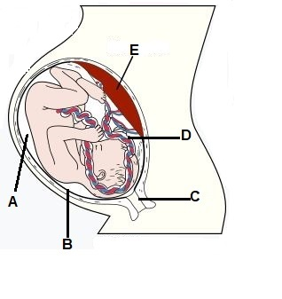

18. The structure labelled as D is the

(a) amnion.

(b) umbilical cord.

(c) placenta.

(d) chorion.

19. Which of the embryonic membranes becomes part of the structure labelled E?

(a) chorion

(b) yolk sack

(c) allantois

(d) amnion

20. The function of bile is to

(a) emulsify lipids in the large intestine.

(b) digest lipids in the stomach.

(c) emulsify lipids in the small intestine.

(d) digest starches in the stomach.

**Questions 21 and 22 refer to the diagram below.**

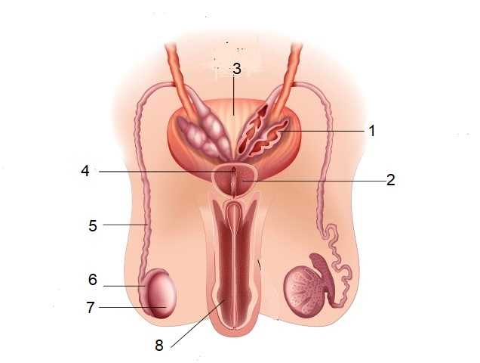

21. Which of the structure/s labelled above function as part of the reproductive and excretory systems?

(a) 3 and 7

(b) 8 only

(c) 5 only

(d) 1 and 8

22. The function of the structure labelled as 6” is to

(a) produce components of semen.

(b) produce testosterone.

(c) store sperm.

(d) connect the seminal vesicles to the prostate gland.

23. The structure within the kidneys responsible for producing urine is the

(a) nephron.

(b) ureter.

(c) renal calyx.

(d) bladder.

24. The cartilage found at the end of long bones that decreases friction at joint surfaces is called

(a) articular.

(b) inelastic.

(c) elastic.

(d) synovial.

**Question 25 refers to the diagram below.**

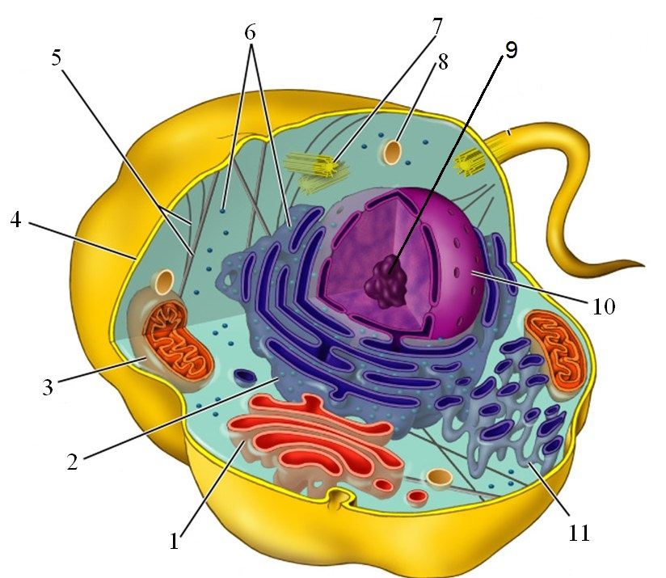

<https://sites.google.com/site/makeithappenedu/assignments/biologycellularbiology>

25. The function of the organelle labelled 1 in the diagram is

(a) packaging materials for secretion from the cell.

(b) providing channels through the cytoplasm of the cell used for storage, synthesis and transport.

(c) where aerobic respiration occurs.

(d) to take materials into the cell or break down worn out organelles.

26. When using a light microscope, the magnification can be altered by

(a) changing the light intensity.

(b) changing the objective lens.

(c) moving the position of the stage.

(d) changing the coarse focus.

27. Although the heart beats intermittently, the blood pressure in the arteries does not drop to zero between beats of the heart and the blood is kept in continuous motion.

Which of the following best explains these observations?

(a) The left and right ventricles contract alternately.  
 (b) Blood is held in reserve in the lymphatic system and supplements blood flow when required.  
 (c) The blood changes in volume with the pressure changes produced by periodic contractions.  
 (d) The walls of the arteries are elastic.

28. The ectoderm layer develops into several body systems and organs in an embryo. This includes the

(a) reproductive system.

(b) nervous system.

(c) skeletal muscles.

(d) bones.

29. The lymphatic system

(a) contains platelets that assist in blood clotting.

(b) releases fluid to maintain blood volume.

(c) helps in the digestion of proteins.

(d) contains leucocytes.

30. Which of the following foods would be chemically digested to the greatest extent in the stomach?

(a) A slice of bread  
(b) An apple  
(c) A carrot  
(d) An egg

**End of Section One**

**Section Two: Short answer 50% (100 Marks)**

This section has **eight** questions. Answer **all** questions. Write your answers in the spaces provided.

Supplementary pages for the use of planning/continuing your answer to a question have been provided at the end of this Question/Answer booklet. If you use these pages to continue an answer, indicate at the original answer where the answer is continued, i.e. give the page number.

Suggested working time: 90 minutes.

**Question 31**  **(10 marks)**

Cell metabolism is crucial to the survival of cells. Many components of a cell are involved in maintaining cell metabolic activity.

Refer to the following diagram to answer the questions that follow.

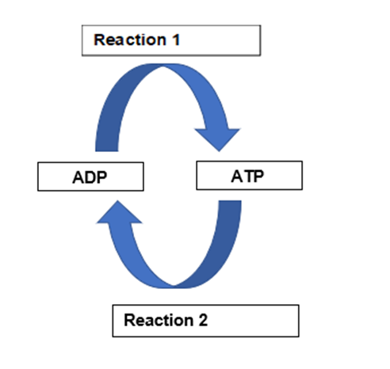

(a) Name a cellular process that will provide the energy for Reaction 1 to occur. (1 mark)

|  |  |
| --- | --- |
| **Description** | **Mark** |
| Respiration/glycolysis/krebs cycle/electron transport chain | 1 |
| **Total** | **1** |

(b) Describe what is occurring in Reaction 2 and identify why this reaction is important to cells. (2 marks)

|  |  |
| --- | --- |
| **Description** | **Mark** |
| Removal of third phosphate/ bond broken between second and third phosphate | 1 |
| Helps release energy from ATP (for other cellular processes that require energy) | 1 |
| **Total** | **2** |

(c) During vigorous physical activity the body has an increased demand for energy to fuel the contracting muscle cells. Often this cannot be sustained by the respiratory and circulatory systems, and the amount of oxygen supplied to cells is reduced.

(i) State the name of the process by which cells are able to release energy in this kind of situation (1 mark)

|  |  |
| --- | --- |
| **Description** | **Mark** |
| Anaerobic respiration | 1 |
| **Total** | **1** |

(ii) State where in the cell this process occurs and what the end product is.

(2 marks)

|  |  |
| --- | --- |
| **Description** | **Mark** |
| Cytoplas/cytosol | 1 |
| Lactic acid | 1 |
| **Total** | **2** |

(d) Mitochondria are organelles found within the cell. Mitochondria have a specialised structure that enables them to carry out their function. Explain why having a highly folded inner membrane and a highly permeable outer membrane would assist mitochondria in their function. (2 marks)

|  |  |
| --- | --- |
| **Description** | **Mark** |
| Inner membrane creates a large surface area for reactions to occur | 1 |
| Permeable outer membrane regulates what enters and exits the mitochondria | 1 |
| **Total** | **2** |

(e) Name a food that contains carbohydrates and a food that contains lipids. (2 marks)

|  |  |
| --- | --- |
| **Description** | **Mark** |
| Carbohydrates – pasta/potato/cake/other…. | 1 |
| Lipids – oil/butter/chips/other…. | 1 |
| **Total** | **2** |

**Question 32 (13 marks)**

Some Human Biology students were investigating the effect of drinking various solutions on

urine output. The two solutions they used were 1 L of plain water and 1 L of a salt solution.

After drinking the solutions, they measured urine output every 30 minutes for 3 hours.

Their results are shown in the table below.

|  |  |  |
| --- | --- | --- |
| **Time (min)** | **Urine output (cm3/30 min)** | |
| **Plain water** | **Sodium chloride solution** |
| Start (solutions drunk) |  |  |
| 30 | 40 | 30 |
| 60 | 350 | 40 |
| 90 | 450 | 50 |
| 120 | 250 | 60 |
| 150 | 80 | 70 |
| 180 | 60 | 50 |

(a) Propose a hypothesis for this investigation. (2 marks)

|  |  |
| --- | --- |
| **Description** | **Mark** |
| Statement linking independent and dependent variable | 1 - 2 |
| Examples:  Drinking pure water increases urine output/ Adding sodium chloride to a solution has no effect on urine output  Drinking a salt solution maintains regular urine output |  |
| **Accept any other reasonable answer Total** | **2** |

(b) Identify the following variables for the students’ investigation:

(i) Independent variable (2 marks)

|  |  |
| --- | --- |
| **Description** | **Mark** |
| Type of solution/concentration of solution | 1 |
| **Total** | **1** |

(ii) Dependent variable

|  |  |
| --- | --- |
| **Description** | **Mark** |
| Urine volume/output | 1 |
| **Total** | **1** |

(c) Graph the data on the grid provided. (5 marks)

(A spare grid can be found at the back of the exam if you wish to have a second attempt).

|  |  |
| --- | --- |
| **Description** | **Mark** |
| Title appropriately - with both independent and dependent variables included  Correctly constructs axes using appropriate scale (Time on X axis, Urine Output on Y axis)  Labelling of axes with correct name and units  Identifies lines using key/labels  Correctly plots points and joins points to form lines | 1-5 |
| **Total** | **5** |

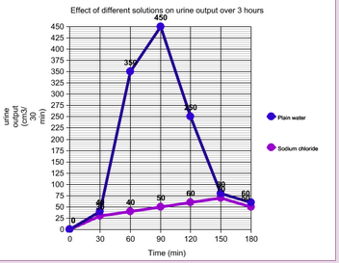

(d) Suggest **one** factor that may affect reliability of the results. (1 mark)

|  |  |
| --- | --- |
| **Description** | **Mark** |
| Any one of: |  |
| * Increase sample space * Repeat trials * Replicate experiment * Other… | 1 |
| **Total** | **1** |

(e) In humans the average amount of glomerular filtrate formed in one hour is 7 L.

However, the average amount of urine produced in an hour is only around 75 mL.

(i) Name the process occurring in the nephron that brings about this change in volume. (1 mark)

|  |  |
| --- | --- |
| **Description** | **Mark** |
| Selective reabsorption/osmosis | 1 |
| **Total** | **1** |

(ii) Explain why the process identified in part (i) must occur in the human body (2 marks)

|  |  |
| --- | --- |
| **Description** | **Mark** |
| Water is a useful substance needed by the body so is reabsorbed back into the blood. | 1 |
| to prevent dehydration/to allow cellular processes to occur | 1 |
| **Total** | **2** |

**Question 33 (14 marks)**

Shown below is a pedigree that outlines the inheritance of a particular disease within a family.

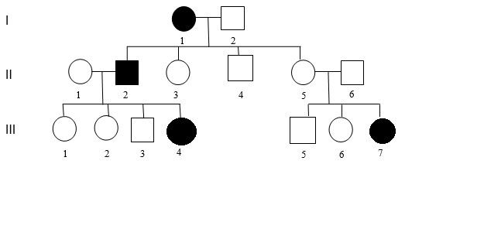

(a) State the sex of Individual I 1. (1 mark)

|  |  |
| --- | --- |
| **Description** | **Mark** |
| female | 1 |
| **Total** | **1** |

(b) Using evidence from the pedigree, explain why the disorder cannot be transmitted by a sex-linked recessive gene. (2 marks)

|  |  |
| --- | --- |
| **Description** | **Mark** |
| Affected female (I 1) had an unaffected son (II 4) | 1 |
| If it were sex-linked, the son would receive one X chromosome from mother and would have to be affected | 1 |
| **Total** | **2** |

(c) Using evidence from the pedigree, explain why the disorder cannot be transmitted by an autosomal dominant gene. (2 marks)

|  |  |
| --- | --- |
| **Description** | **Mark** |
| If it was autosomal dominant then two unaffected parents could not have an affected child | 1 |
| II 5 and II6 are unaffected which means they do not have the dominant allele but they have produced an affected offspring III7 | 1 |
| **Total** | **2** |

(d) Assume that the individual II 1 has a genotype **Bb**. Individuals II 1 and II 2 have another child. What is the probability that the child will be affected? Show your working.

(3 marks)

PI Bb x bb

B b

|  |  |
| --- | --- |
| Bb | bb |
| Bb | bb |

b

b

2 Bb: 2 bb

|  |  |
| --- | --- |
| **Description** | **Mark** |
| * Correct genotypes of father listed - bb * Correct genotypes of potential offspring inside Punnett square | 1  1 |
| Probability of producing a child with disease = ½ or 50% | 1 |
| **Total** | **3** |

(e) Which male in generation 3 is **more unlikely** to pass on the allele to his future children? Explain your reasoning. (3 marks)

|  |  |
| --- | --- |
| **Description** | **Mark** |
| III5 | 1 |
| II3 must have one b allele as they have an affected parent therefore the probability of passing it on to his children is 50% | 1 |
| III5 could be BB or Bb therefore the chance of passing the b on to his children lower/less than III3 | 1 |
| **Total** | **3** |

(f) If ll 5 becomes pregnant again, describe **one** test during pregnancy this couple could have to find out the genotype of the unborn child and state **one** risk associated with this method of prenatal testing. (3 marks)

|  |  |
| --- | --- |
| **Description** | **Mark** |
| **Any one of the following examples.** |  |
| **1. Amniocentesis**  Removal of amniotic fluid (16th-20th week pregnancy) from amniotic sac – about 10 – 20 ml  Foetal cells in fluid examined | 1-2 |
| Risk- infection, miscarriage or damage to baby | 1 |
| **2. Chorionic villus sampling**  Obtain foetal cells from chorion using needle aspiration.  Cells examined in the same way as amniocentesis | 1-2 |
| Risk- miscarriage | 1 |
| **Total** | **3** |

**Question 34 (11 marks)**

Paternity testing involves a number of procedures used to determine the biological father of a child. One of these is testing for blood groups.

The following shows the results of blood group testing for a mother, her child, and the **three** possible biological fathers.

**Results: Testing for ABO blood groups**

Mother’s blood group: B

Child’s blood group: O

Possible biological father’s blood groups

* Father 1: O
* Father 2: A
* Father 3: B

(a) Describe the mode of inheritance for the ABO blood grouping system. (2 marks)

|  |  |
| --- | --- |
| **Description** | **Mark** |
| It is codominant between A and B | 1 |
| And the O/no antigen allele is recessive | 1 |
| **Total** | **2** |

(b) Identify if any male(s) can be excluded as the possible biological father of the child. Use Punnett squares to help justify your answer (4 marks)

**Possible father 1**

Father

Mother

|  |  |  |
| --- | --- | --- |
|  | i | i |
| IB | IB i | IB i |
| i | ii | ii |

**Possible father 2**

Father

Mother

|  |  |  |
| --- | --- | --- |
|  | IA | i |
| IB | IAIB | IBi |
| i | IAi | ii |

**Possible father 3**

Father

Mother

|  |  |  |
| --- | --- | --- |
|  | IB | i |
| IB | IBIB | IBi |
| i | IBi | ii |

|  |  |
| --- | --- |
| **Description** | **Mark** |
| 1 mark per Punnett square | 3 |
| All fathers could produce an O blood group child | 1 |
| **Total** | **4** |

(c) ABO blood grouping is based on genes that code for proteins that can be found on the

surface of erythrocytes.

(i) State the function of erythrocytes.

(1 mark)

|  |  |
| --- | --- |
| **Description** | **Mark** |
| Carry oxygen (and carbon dioxide) | 1 |
| **Total** | **1** |

(ii) Describe the structure of an erythrocyte, and explain how the structure suits its

function.

(4 marks)

|  |  |
| --- | --- |
| **Description** | **Marks** |
| A biconcave disc (with no nucleus) | 1 |
| Increases surface area | 1 |
| Allows for presence of more haemoglobin | 1 |
| Which means more oxygen can be transported | 1 |
| **Total** | **4** |

**Question 35 (11 marks)**

(a) On the diagram of the heart shown below, label the aorta, the pulmonary artery and the right ventricle. (3 marks)

|  |  |
| --- | --- |
| **Description** | **Marks** |
| Aorta correctly labelled | 1 |
| Pulmonary artery correctly labelled | 1 |
| Right ventricle correctly labelled | 1 |
| **Total** | **3** |

Aorta

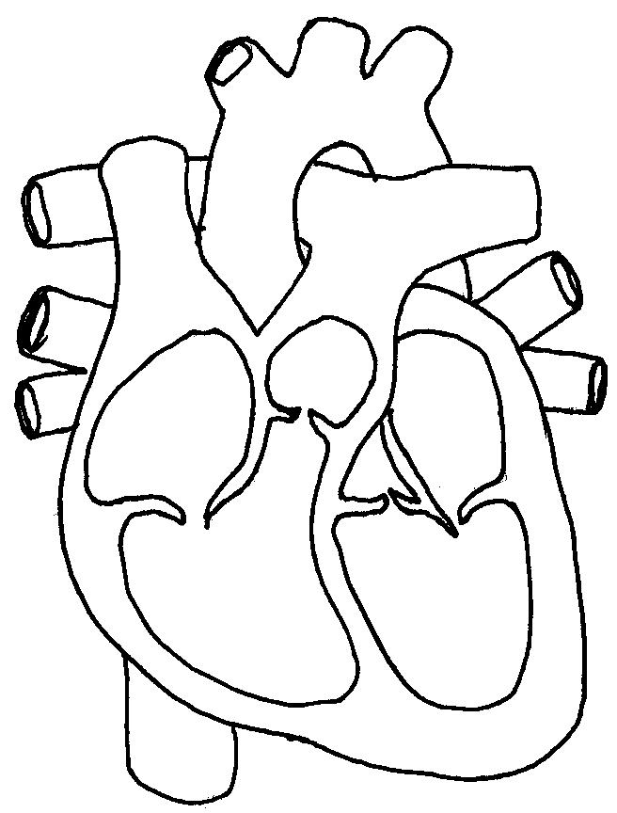

Right

ventricle

Pulmonary artery

(b) All babies are born with a “hole in their heart” that closes over once the lungs inflate with oxygen. State the name given to this feature of a foetal heart. (1 mark)

|  |  |
| --- | --- |
| **Description** | **Mark** |
| Foramen ovale | 1 |
| **Total** | **1** |

Occasionally a baby is born with a serious condition of the heart. There are separate abnormalities within the heart that occur as a result of this condition including that the aorta comes primarily out of the right ventricle instead of the left and the muscular wall between the right and left sides of the heart is incomplete, so the blood in the left and right ventricles is not kept separate.

(c) In a baby with the condition described above, is the hole between the ventricles an advantage or a disadvantage? Explain your choice. (3 marks)

|  |  |
| --- | --- |
| **Description** | **Marks** |
| Advantage | 1 |
| Hole allows for some mixing of oxygenated and deoxygenated blood to go to right ventricle | 1 |
| This blood that does contain some oxygen can then be pumped to the body via the misplaced aorta. | 1 |
| **Total** | **3** |

(d) Many vital organs of a foetus are not required to function whilst it is in the uterus. After birth, however, rapid changes need to occur within the foetal circulation to enable the baby to survive outside the womb. Describe **two** changes (besides the hole in the heart closing) that will occur.

(4 marks)

|  |  |
| --- | --- |
| **Description** | **Marks** |
| Blood flow through ductus arteriosus (lung bypass) decreases/ductus arteriosus closes off/deteriorates | 1 |
| Blood now flows to the lungs via the pulmonary artery | 1 |
| Blood flow through ductus venosus (liver bypass) decreases/ductus venosus closes off/deteriorates | 1 |
| Blood starts to flow through the liver | 1 |
| **Total** | **4** |

**Question 36 (12 marks)**

(a) Sketch a graph that shows the changes in thickness of the endometrium throughout one complete menstrual cycle. Indicate on the graph when ovulation would also be occurring at the ovaries.

(2 marks)

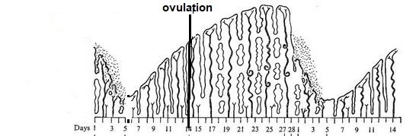

(b) Outline the function of the endometrium. (1 mark)

|  |  |
| --- | --- |
| **Description** | **Marks** |
| Allows for implantation of a blastocyst/provides nourishment for developing embryo | 1 |
| **Total** | **1** |

(c) Describe how progesterone affects the endometrium during the menstrual cycle.

(1 mark)

|  |  |
| --- | --- |
| **Description** | **Marks** |
| **Any one of** |  |
| Endometrium continues to thicken  Glands secrete mucous  Becomes more vascularised/glandular | 1 |
| **Total** | **1** |

(d)  Describe and explain how the hormonal regulation of both the ovarian and menstrual cycle changes after fertilisation.

(5 marks)

|  |  |
| --- | --- |
| **Description** | **Marks** |
| Corpus luteum is maintained by HCG/continues to secrete progesterone | 1 |
| Endometrium is maintained by progesterone/does not shed | 1 |
| High levels of progesterone inhibit release of FSH and LH | 1 |
| No more follicles mature in ovary | 1 |
| No eggs are released/ovulation cannot occur | 1 |
| **Total** | **5** |

(e) About 1 in 6 couples in Australia wanting to have children experience difficulties in getting pregnant. Advancements in assisted reproductive technology (ART) have resulted in a range of treatments for infertility being made available. One such assisted reproductive technology is GIFT.

(i) What does GIFT stand for? (1 mark)

|  |  |
| --- | --- |
| **Description** | **Marks** |
| Gamete Intra fallopian transfer | 1 |
| **Total** | **1** |

(ii) Describe the GIFT procedure. (2 marks)

|  |  |
| --- | --- |
| **Description** | **Marks** |
| eggs and sperm mixed together immediately after eggs are collected | 1 |
| Injected into woman’s fallopian tubes (before zygote is formed) | 1 |
| **Total** | **2** |

**Question 37 (18 marks)**

The diagram below shows the structure of a long bone.

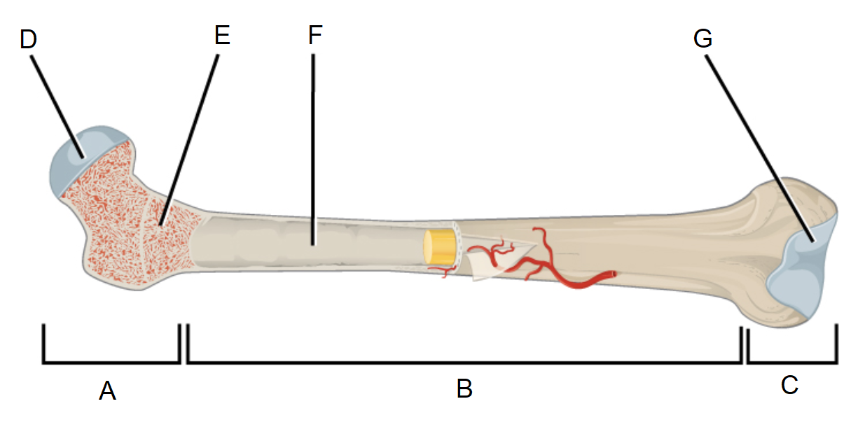

(a) State the name of the following parts labelled in the diagram. (2 marks)

|  |  |
| --- | --- |
| **Description** | **Marks** |
| A – Epiphysis | 1 |
| B - Diaphysis | 1 |
| **Total** | **2** |

(b) The parts labelled F and E contain two different types of bone marrow. Name and describe the function of the different types of marrow.

(4 marks)

|  |  |
| --- | --- |
| **Description** | **Marks** |
| Yellow marrow | 1 |
| For storage of fat | 1 |
| Red marrow | 1 |
| For production of blood cells | 1 |
| **Total** | **4** |

(c) People often think that bone is dead. Explain why this is not a true statement. (2 marks)

|  |  |
| --- | --- |
| **Description** | **Marks** |
| Bone is a tissue – meaning it is made up of cells | 1 |
| Cells are the defining characteristic of living things – therefore alive | 1 |
| **Total** | **2** |

The movements at any particular joint are possible because of its structure, including the presence of articular cartilage and the skeletal muscles that contract to pull the bone into a different position.

(d) The knee joint is an example of a synovial joint. State **two** characteristics of all synovial joints. (2 marks)

|  |  |
| --- | --- |
| **Description** | **Mark** |
| Any two of: |  |
| * Freely moveable * Contain synovial fluid * Have a synovial cavity * Have an articular capsule * Other…. | 1-2 |
| **Total** | **2** |

(e) (i) Outline the function of articular cartilage at the joint. (1 mark)

|  |  |
| --- | --- |
| **Description** | **Marks** |
| To decrease friction/allow for smooth movement at the joint | 1 |
| **Total** | **1** |

(ii) State and describe the structure of the type of cartilage that includes articular cartilage.

(3 marks)

|  |  |
| --- | --- |
| **Description** | **Marks** |
| Hyaline | 1 |
| Contains densely packed collagen fibres | 1 |
| Fine/thin/small collagen fibres | 1 |
| **Total** | **3** |

(f) Movement at a synovial joint often occurs because of the interactions between antagonistic pairs of muscles. Describe how the biceps and triceps work together to allow flexion to occur at the elbow joint.

(4 marks)

|  |  |
| --- | --- |
| **Description** | **Mark** |
| Biceps act as the agonist/prime mover |  |
| triceps act as the antagonist |  |
| When biceps contract, triceps relax |  |
| This pulls bones of forearm closer to the humerus/upper arm – flexing the elbow |  |
| **Total** | **4** |

**Question 38 (11 marks)**

1. DNA is made of units called nucleotides. Draw a labelled diagram of a nucleotide to show its constituent parts. (3 marks)

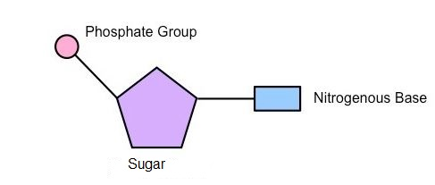

|  |  |
| --- | --- |
| **Description** | **Marks** |
| Sugar, phosphate and base labelled correctly | 1 |
| One base connected to sugar AND one phosphate connected to the other side of the sugar | 1 |
| Only a single nucleotide drawn/ correct representation of a single nucleotide | 1 |
| **Total** | **3** |

1. Which of the labelled part/s in your diagram may vary from nucleotide to nucleotide?

(1 mark)

|  |  |
| --- | --- |
| **Description** | **Marks** |
| Nitrogenous base | 1 |
| **Total** | **1** |

DNA codes for the sequence of amino acids in a protein. The diagram below shows a section of a DNA template strand.

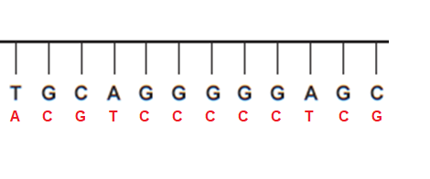

(c) (i) Use the base pair rule to create the complementary DNA strand. Draw it on the diagram above. (1 mark)

(1 mark for correct strand - see above)

(ii) Write the sequence of the mRNA strand that would be produced from the DNA template strand. (1 mark)

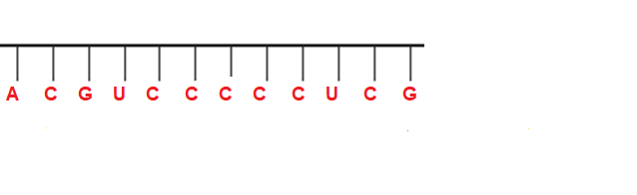

(1 mark for correct sequence, don’t need to draw strand)

(d) Describe how mRNA is created from the DNA template strand.

(5 marks)

|  |  |
| --- | --- |
| **Description -any 5 of** | **Marks** |
| * DNA unwinds/unzips because of RNA polymerase | 1-5 |
| * RNA polymerase binds complementary free floating nucleotides to the… |
| * Template strand of DNA (mRNA is complement of template strand) |
| * Promoter gene indicates start of transcription/chemical messenger indicates start of transcription |
| * uracil instead of thymine attached to adenine for mRNA molecule |
| * introns are removed from mRNA/exons left on mRNA |
| * coding strand of DNA will be identical to mRNA molecule (except for uracil) |
| **Total** | **5** |

**End of Section Two**

**Section Three: Extended answer 20% (40 Marks)**

Answer any **two** questions from Questions 39 to 41.

Indicate the questions you will answer by ticking the box next to the question. Write your answers on the pages that follow.

**Question 39 (20 marks)**

(a) In the human body the functioning of the different body systems is closely related to the structure of the tissues and organs that connect together to create the system. For each of the following, describe the structure of the component and explain how the structure is linked to its function. (12 marks)

(i) Alveolus

(ii) Nephron

(iii) Villus

|  |  |
| --- | --- |
| **Description** | **Marks** |
| Mark per description plus mark per appropriate **linked** explanation of function – up to a total of 4 per structure |  |
| **Alveolus** |  |
| Spherical in shape | 1 |
| Spherical shape allows for maximum SA:Vol for gas exchange | 1 |
| Extensive capillary supply | 1 |
| Allows for fast exchange of gases between alveoli and blood | 1 |
| Thin, walls can be only one cell thick | 1 |
| Allows for efficient/easy diffusion of gases during gas exchange | 1 |
| Moist due to location within the chest cavity | 1 |
| Moisture allows gases to dissolve allowing for diffusion and thus gas exchange | 1 |
| Numerous, there is an extremely large number of alveoli | 1 |
| Vast numbers create a very large surface area for gas exchange | 1 |
| **Nephron** |  |
| Numerous, there is an extremely large number of nephrons | 1 |
| Vast numbers create a very large SA for reabsorption and tubular secretion | 1 |
| Each nephron has two sets of convolutions and a long loop | 1 |
| The long length provides a large SA for reabsorption and tubular secretion | 1 |
| The afferent arteriole has a wider diameter than the efferent arteriole | 1 |
| This raises the pressure in the glomerulus to allow for fluid to be filtered from the blood | 1 |
| **Villus** |  |
| Villi are very numerous | 1 |
| A large number of villi allow for maximum SA for absorption of nutrients | 1 |
| Villi are themselves covered in microvilli | 1 |
| SA is even further maximised for absorption of nutrients | 1 |
| Villi are continually moving due to the muscular movement of the intestinal wall | 1 |
| Movement maximises the amount of nutrient that contact the villi and can them be absorbed | 1 |
| Villi contain a lacteal and a blood capillary | 1 |
| These vessels allow for the absorption of all of the products of digestion |  |
| **Total** | **12** |

(b) Enzymes are involved in chemical reactions that occur within cells. Describe how enzymes function and explain why there is a need for so many different enzymes in the body. (8 marks)

|  |  |
| --- | --- |
| **Description** | **Marks** |
| **So many needed because** |  |
| One enzyme will combine with only one substrate | 1 |
| Therefore each enzyme is involved in one reaction only | 1 |
| Body produces many different enzymes due to many reactions it performs. | 1 |
| **How they work-Any 5 of the following** |  |
| Enzymes reduce/lower the activation energy required for a chemical reaction to proceed. | 1 |
| Lock and key model | 1 |
| Substrate binds with enzyme at active site | 1 |
| Forms enzyme-substrate complex | 1 |
| The substrate can undergo an anabolic or catabolic reaction |  |
| Enzyme remains unchanged | 1 |
| Enzymes can use induced fit model | 1 |
| In this model it is accepted that the active site of the enzyme modifies to fit the substrate | 1 |
| **Total** | **8** |

** Question 40 (20 marks)**

(a) Movement or motion takes place as a coordinated action between muscles, bones and joints. Describe the structure of skeletal muscle and how the sliding filament theory works to explain the contraction and relaxation of muscle. (12 marks)

|  |  |
| --- | --- |
| **Description** | **Marks** |
| **Structure of muscle** |  |
| The entire muscle is connected to the skeleton by tendons and/or the thickest part is the belly |  |
| Bundles of muscle are held together by connective tissue and/or contain nerves and blood vessels |  |
|  |  |
|  |  |
| **Sliding filament theory** |  |
|  |  |
|  |  |
|  |  |
|  |  |
| **Total** | **12** |

(b) Stem cells are promoted as “the way of the future” for the treatment of many illnesses. Describe what a stem cell is and explain the threedifferent potency types of stem cells. (8 marks)

|  |  |
| --- | --- |
| **What a stem cell is– any 2 of the following** | **Marks** |
| A cell that is not specialised. | 1 |
| A cell capable of repeated mitosis. | 1 |
| A cell that can differentiate into specialised cells. | 1 |
| **Total** | **2** |
| **3 potencies of stem cells – can be** |  |
| Totipotent | 1 |
| Can differentiate into any type of cell including those of the body and the embryonic membranes | 1 |
| **Total** | **2** |
| Pluripotent | 1 |
| Can differentiate into any cell that makes up the body | 1 |
| **Total** | **2** |
| Multipotent | 1 |
| Can differentiate into the cells contained in one type of tissue | 1 |
| **Total** | **2** |
| **Total** | **8** |

** Question 41 (20 marks)**

(a) Pregnancy requires the fertilisation of an ovum by a spermatozoon. Gametogenesis is the process by which the gametes are produced. Compare and contrast the two types of gametogenesis. (8 marks)

|  |  |  |
| --- | --- | --- |
| **Description** | | **Marks** |
| **Spermatogenesis** | **Oogenesis** | 1 |
| Located in seminiferous tubules of testes | Located in ovary | 1 |
| Begins at puberty and continues through adult life | Begins prior to birth and continues to menopause | 1 |
| End result is 4 mature cells | End result is 1 mature cell and up to 3 polar bodies | 1 |
| Produces sperm/spermatozoon | Produces ova/egg | 1 |
| Both produce genetically unique cells | | 1 |
| Both produce haploid cells containing 23 chromosomes | | 1 |
| Both require the processes of mitosis and meiosis | | 1 |
| Both require germ/stem cells to begin | | 1 |
| **Total** | | **8** |

(b) Modern science has introduced new and highly reliable methods of birth control or contraception. A condom is a mechanical barrier whilst the oral contraceptive pill is a hormonal method. Intra-uterine devices (IUDs) provide another possible choice for contraception. Describe and explain how each of the named contraceptives work to prevent pregnancy, and the advantages and disadvantages of each. (12 marks)

|  |  |
| --- | --- |
| **Description** | **Marks** |
| **Condom** |  |
| A thin sheath of latex rubber rolled onto the penis prior to intercourse | 1 |
| Creates a barrier that prevents sperm from entering the vagina. Sperm are unable to fertilise the egg | 1 |
| Advantage – any of; easy to buy, relatively cheap, also protects against STIs | 1 |
| Disadvantage – any of; may affect spontaneity, needs to have cooperative partners | 1 |
| **Oral Contraceptive Pill** |  |
| A pill taken daily that contain (substances similar to) oestrogen and progesterone | 1 |
| The hormones prevent the release of a mature egg from the ovary, alter the endometrium making it less suitable for implantation and thicken cervical mucous | 1 |
| Advantage – any of; helps with regular reliable periods, reduced incidence of ovarian and uterine cancer | 1 |
| Disadvantage – doctor’s prescription required, must be taken daily, possible side effects, no protection against STIs | 1 |
| **IUD** |  |
| Small device made of plastic containing either hormones or copper inserted into the uterus | 1 |
| Hormones work by making the endometrium unsuitable for implantation and thicken cervical mucous  Copper works by effecting the movement of sperm and causing changes to the endometrium | 1 |
| Advantage – any of; effective, long lasting, easily reversed, once in place no further action is required, can be used as emergency contraception | 1 |
| Disadvantage – any of; must be inserted by a doctor, may cause pain and bleeding with menstruation, no protection against STIs | 1 |
| **Total** | **12** |